White Paper

Pilot Study: Do California highways act as barriers to gene flow for ground-dwelling mammals?

Amanda Coen, Andrea Schreier, Fraser Shilling

December 31, 2015

Final Version

Logo here



U.S. DOT Disclaimer

The contents of this report reflect the views of the authors, who are responsible for the facts and the accuracy of the information presented herein. This document is disseminated under the sponsorship of the U.S. Department of Transportation’s University Transportation Centers Program, in the interest of information exchange. The U.S. Government assumes no liability for the contents or use thereof.

Acknowledgment of Sponsorship

This study was funded by a grant from the National Center for Sustainable Transportation (NCST), supported by the U.S. Department of Transportation and by Caltrans through the University Transportation Centers program. The authors would like to thank the NCST and Caltrans for their support of university-based research in transportation, and especially for the funding provided in support of this project.

TABLE OF CONTENTS

Introduction 1

Materials and Methods 2

Study Highways 2

Molecular Methods 2

Data Analysis 3

Results 4

Sample Collection and Species Identification 4

Genetic Diversity 4

Genetic Connectivity 5

Discussion 6

Future Work 7

Acknowledgements 7

Tables and Figures 8

References 13

Pilot Study: Do California highways act as barriers to gene flow for ground-dwelling mammals?

**Key Findings**

We discovered little evidence of coyote-population genetic structure generated by highways at our Bay Area and Sierra Nevada foothill study sites.

The lack of genetic structure suggests that either 1) our study highways are permeable to coyote movement or 2) highways do constrain coyote movement but have not existed long enough to produce detectable signals of genetic structure.

EXECUTIVE SUMMARY

Roads have the potential to fragment wildlife populations, leading to genetic diversity loss, inbreeding, and increased extinction risk for small, isolated populations. In this study, we studied coyote populations due to their important role as meso-carnivores and as a model to investigate how four Northern California highways affect gene flow of ground-dwelling mammals. We collected coyote scat samples from opposite sides of a stretch of I-580 and I-680 in the Bay Area and I-80 and SR 50 in the Sierra Nevada foothills. We extracted DNA and genotyped each coyote at 13 microsatellite loci. We estimated genetic diversity and determined how that diversity was partitioned across the landscape in each region.

Genetic diversity among coyotes was high and comparable to other studies. We found little evidence of contemporary genetic structure across highways in the Bay Area or Sierra Nevada foothills. In the Bay Area, two populations were identified but signals of population structure did not correspond to opposite sides of the highways. In the Sierra Nevada foothills, only a single population was identified. There are two alternative explanations for these findings. Our study highways may be permeable to coyote movement due to successful road crossings or use of crossing structures. Alternatively, our study highways may not have existed long enough to produce detectable signals of population structure. Because coyotes are a relatively large bodied, wide-ranging species with high genetic diversity, results from this study may not be generalizable to endangered or small-bodied wildlife.

# Introduction

Roads can negatively affect wildlife by destroying important habitats, causing mortality through wildlife-vehicle collisions, and fragmenting populations (Coffin 2007). Population fragmentation occurs when roads act as physical or functional barriers to wildlife dispersal. Roads acting as barriers to dispersal will decrease gene flow among the populations they fragment (Gerlach and Musolf 2000; Clark et al. 2010; Delaney et al. 2010). Small, fragmented populations receiving little outside gene flow are more susceptible to genetic diversity loss and inbreeding. Populations with low genetic diversity are less able to adapt to environmental changes, particularly those occurring on a short timescale (e.g. Reusch et al. 2005). Inbreeding, or mating between close relatives, can lead to inbreeding depression which increases a population’s extinction risk by decreasing the fitness of individuals (Frankham 1996). Therefore, by disrupting gene flow, roads can increase the likelihood that wildlife populations will be locally extirpated, particularly in urban areas (Riley et al. 2014a).

Transportation agencies are mandated to reduce the negative effects of roads on wildlife populations, including disruption of gene flow. Overpasses or undercrossings may be installed to restore natural gene flow patterns. However, to effectively plan these and other mitigation activities, transportation agencies must know which roads to target, whether or not existing structures are providing wildlife passage, and which species are most affected. However, the degree to which roads impede wildlife movements and gene flow varies by road and species. Physical characteristics of roads (e.g. width, gradient, traffic volume) can affect their permeability to different species (Gerlach and Musolf 2000; Marsh et al. 2005; Charry and Jones 2009). In addition, a single road can affect different species to varying degrees due to species-specific behavior patterns. The Trans-Canada Highway is a significant dispersal barrier for grizzly bears (*Ursus arctos*) but not for black bears (Ursus *americanus*; Sawaya et al. 2014). Therefore the impacts of roads on wildlife gene flow cannot be generalized in space or among species.

Although others have shown that Southern California highways, which exist in highly-disturbed landscapes, can significantly impede gene flow of numerous taxa (Riley et al. 2006, 2014, Delaney et al. 2010), few studies have investigated the effect of Northern California highways on wildlife gene flow. In this pilot study, we use the coyote, a wide-ranging mesopredator, both because of its ecosystem role as a predator and as a model species to investigate how highways affect gene flow of terrestrial vertebrates in Northern California. The coyote is an ideal model for this type of investigation because it is abundant, occupies most habitats (pristine to urban), and leaves conspicuous scats that can be collected for genetic analysis. In this study we sampled coyote scats in open space areas on either side of long stretches of I-580 and I-680 in the Bay Area and I-80 and SR 50 in the Sierra Nevada foothills. We then use population genetic analysis to determine whether those highways acted as physical or functional barriers to coyote gene flow.

# Materials and Methods

## Study Highways

### Interstates 580 and 680

We studied coyote separated by Interstates 680 and 580 in the inland valleys of the East Bay (hereafter referred to as Bay Area). Both highways have 10 lanes, center median barriers, and are heavily trafficked, travelled by >180,000 vehicles daily (Caltrans, 2014 Traffic Volumes on California State Highways). The East Bay region is a heavily populated urban and suburban matrix interspersed with regions designated as open space parkland (Figure 1A). Sampling was conducted in 115.8 square km of open space and parkland in regions adjacent to the study highways. All samples were collected ≤ 10 km from the highways. Although the East Bay region is highly developed, coyotes have been shown to inhabit urban and suburban habitats and therefore development alone is not likely to act as a barrier to dispersal (Atkinson and Shackelton 1991, Grinder and Krausman 2001, Grubbs and Krausman 2009). Therefore, the highways are the only major landscape feature likely to disrupt gene flow in the absence of rivers or other geological features.

### Interstate 80 and State Route 50

Within the lower Sierra Nevada Foothills, we studied coyotes separated by Interstate 80 and State Route 50 (Figure 1B). Both highways are 6-10 lane highways in the study area, with central median barriers and daily traffic volumes that ranges from >140,000 vehicles/day in the southern section to 65,000 vehicles/day in the northern, more rural region of our study area. Sampling was conducted in 130 square km of open space and parklands in regions adjacent to the study highways. All samples were collected ≤ 10 km from the highways. The southern portion of the study area is comprised of urban matrix surrounding Sacramento with human population densities decreasing as the highways travel east and north from the city. In addition to the presence of the study highways, the American River mainstem and the North Fork American River run through the center of the study region and may serve as dispersal barriers.

## Molecular Methods

### Sample Collection and DNA Extraction

We collected mesopredator fecal samples along hiking transects in the study areas from November 2014 to August 2015 (Figure 1; Table 1). A fraction of each scat was preserved in 95% ethanol in the field for later DNA extraction. GPS points recorded the exact location where each sample was collected. Fecal samples were stored at 4⁰C upon return to the lab. DNA was extracted using the QIAmp Mini Stool Kit (QIAGEN). To minimize opportunities for contamination, all extractions were done in a laboratory isolated from post-PCR products and lab benchtops were bleached before and after fecal samples were handled.

### Species Identification and Genotyping

Samples were identified to the species level by sequencing a portion of the cytochrome *b* gene. Cytochrome *b* is a region of mitochondrial DNA commonly used for distinguishing between mammal species. All samples identified as non-target species (e.g. bobcat, gray fox) were archived for future study. Samples confirmed to have originated from coyote were genotyped using 13 microsatellite loci optimized for use with coyote fecal DNA: AHTh171, AHT137, ANT142, CPH11, CPH18, CXX279, CXX374, CXX468, CXX602, INU055, REN54P11, REN162C04, and REN169O18 (Quinn & Sacks 2014). Loci were multiplexed using the QIAGEN Multiplex PCR Kit (QIAGEN) with two multiplexes containing 7 loci each. Two microliters of PCR product were combined with 9.5 μl of highly deionized formamide and 0.5 μl of Genescan 500 LIZ size standard (Life Technologies; LT). Fragment analysis was performed on an ABI PRISM 3730 DNA Analyzer (LT) and alleles were scored with STRand software (Locke and Toonen 2007). Negative controls were included with each PCR run to detect contamination. Samples were genotyped three times at each locus to detect and correct for allelic dropout and other genotyping errors commonly encountered when working with degraded samples.

## Data Analysis

### Genetic Diversity

Before any analyses were conducted, microsatellite loci were tested for conformance to Hardy Weinberg equilibrium and linkage equilibrium using GenAlEx version 6.502 (Peakall and Smouse 2006; Peakall and Smouse 2012) using sequential Bonferroni corrections to account for multiple comparisons (Rice 1989). We then examined genetic diversity within and among coyote populations in our study areas by calculating the number of alleles, allelic richness, and expected and observed heterozygosity (He, Ho) in GenAlEx. Because small sample sizes can negatively bias genetic diversity estimates, we did a rarefaction analysis in HP-Rare (Kalinowski 2005) to develop estimates of allelic richness corrected for unequal sample sizes. Additionally, we measured pairwise relatedness (r) among coyotes within and among sampling locations in GenAlEx to identify close relatives (first and second order) in our dataset.

### Genetic Connectivity

We used STRUCTURE version 2.3.4 (Pritchard et al. 2000) to examine how coyote genetic diversity was partitioned across our sampling locations. STRUCTURE, a Bayesian clustering algorithm, inferred the most likely number of populations in the Bay Area and Sierra Nevada foothills study areas. Since our sampling was conducted on a relatively fine scale for a wide-ranging species, we expected population structuring to be weak, even if highways were significant barriers to gene flow. Therefore, we used the Hubisz et al. (2009) LOCPRIOR model that improves STRUCTURE’s ability to detect weak population structure by using geographic sampling location as prior information. We also used the population admixture model with correlated allele frequencies. Each run consisted of 100,000 Markov chain Monte Carlo iterations following a burn-in period of 10,000 iterations. We tested the likelihood of K=1 through K=4 for the Bay Area and K=1 through K=6 for the Sierra Nevada foothills dataset, where K is the number of populations. Ten replicates were conducted for each K. We determined K by examining plots of the mean likelihood value ln Pr(X|K) and calculating ∆K (Evanno et al. 2005) in STRUCTURE HARVESTER (Earl and von Holdt 2012). The program CLUMPP (Jakobsson and Rosenberg 2007) was used to compile individual assignments across replicates and we used custom R code based on the ggplot2 package to create bar plots to visualize results.

We also examined population genetic structure by estimating pairwise FST values (a measure of genetic differentiation) among all sampling locations in the AMOVA framework in GenAlEx. Significance of pairwise FST values was determined through 999 permutations. We also calculated Nei’s genetic distance (Nei 1972; Nei 1978) among sampling locations in GenAlEx. Nei’s genetic distance matrix was paired with a geographic distance matrix to test for isolation by distance (IBD), which occurs when genetic distance between sampling locations increases with geographic distance. Geographical distance was calculated as the Euclidean distance between pairs of individual sample locations, recorded as GPS points (decimal latitude and longitude). For individuals that were detected twice in our sampling locations, we used the average of two locations to represent their detection center. The relationship between genetic and geographic distance in the Bay Area and Sierra Nevada foothills was assessed with Mantel tests in the R package Ecodist (Goslee et al. 2015). To determine whether the study highways have a significant effect on genetic distance between sampling locations, we performed partial Mantel tests, also in Ecodist, where we assigned a dummy variable to pairs of populations to designate whether they were on the same side (=0) or different side (=1) of the highway from each other.

# Results

## Sample Collection and Species Identification

We collected a total of 251 scats from our hiking transects. The species identification test revealed that 128 of these samples originated from coyote. We were able to obtain high quality genotypes (data at >85% of loci) for 83 individuals (Table 1).

## Genetic Diversity

For populations that contained no close relatives (see below), no significant deviation from linkage equilibrium was observed at any loci after implementing the sequential Bonferroni correction (alpha = 0.0039). However, eight loci deviated significantly from Hardy Weinberg equilibrium in at least one population. Seven of eight loci were out of Hardy Weinberg equilibrium only in W680 or S80-N50.

Both sampling regions showed high levels of genetic diversity. The total number of alleles observed within sampling locations ranged from 54-99 and 37-108 in the Bay Area and Sierra Nevada foothills, respectively. When rarefaction was conducted, allelic richness ranged from 3.8-4.2 in the Bay Area and 2.9-3.9 in the Sierra Nevada foothills (Table 1). Measures of Ho and He (estimates of gene diversity in a population) were high in both regions with Ho ranging from 0.60-0.72 in the Bay Area and 0.68-0.89 in the Sierra Nevada foothills (Table 1). Pairwise relatedness values within sampling locations showed that most individuals were not closely related, although nine and 11 pairs of first order (e.g. parent-offspring, full sibling; r ≈ 0.50) or second order relatives (e.g. half-sibling, avuncular; r ≈ 0.25) relatives were detected W680 (r = 0.25 - 0.40) and S80-N50, respectively (r = 0.26 - 0.46).

## Genetic Connectivity

STRUCTURE revealed two genetic clusters in the Bay Area (mean ln Pr(X|K) = -1226.13; Figure 2). One cluster consisted of 14 individuals from the W680 sampling location and one from the E680 location while the second cluster contained individuals from all three locations. Within the Sierra Nevada foothills, a single genetic cluster was best supported (mean ln Pr(X|K) = -2406.65). Pairwise FST values found no significant genetic differentiation in the Bay Area and Sierra Nevada Foothills (Table 2).

Mantel tests revealed no association between genetic and geographic distance in the Bay Area or Sierra Nevada foothills (r= 0.95, p = 1.00; r = -0.67, p = 0.33, respectively). Partial Mantel tests in the Bay Area suggested that there was no significant genetic divergence across either highway (I-580 r = -1.00, p = 0.67; I-680 r = -1.0, p = 0.33). Within the Sierra Nevada foothills, no genetic divergence was observed from sampling locations on opposite sides of the highways (r = 1.00, p = 1.00).

# Discussion

Highways can act as a partial or total dispersal barrier for even wide ranging species, resulting in genetic differentiation between populations fragmented by roads over time due to a lack of gene flow (Riley et al. 2006, Ernest et al. 2014, Sawaya et al. 2014). The aim of this study was to determine whether highways disrupt wildlife gene flow in the Bay Area and the Sierra Nevada foothills, using coyote as a model species.

We found that coyote populations within both study regions were genetically diverse, with high heterozygosity and allelic richness for all sampling locations. These results are in line with other findings of coyote genetic diversity throughout California (Sacks et al. 2005; Riley et al. 2006). Such high levels of genetic diversity suggest that both the Bay Area and Sierra Nevada foothills support large numbers of coyotes.

Unlike Riley et al. (2006), who found significant genetic structure between the north and south sides of Highway 101 (N=68), we did not detect any signal of population structure related to highway presence. If highways were disrupting coyote gene flow, we would expect to see distinct populations corresponding to each side of the study highway. For example, if the Bay Area highways were impermeable to coyote gene flow, we would expect to see three distinct populations, corresponding to the west side of I-680, the east side of I-580, and south of I-580/west of I-680 (Figure 3). In contrast, Structure analysis found only two genetic clusters in the Bay Area and they did not correspond to opposite sides of the highways (Figure 2). The “green” cluster containing primarily W680 individuals also contained one individual from E680. Although this cluster was significantly differentiated from all others, it also contained a number of close relatives and deviated from Hardy Weinberg equilibrium. The presence of close relatives in a sample can create spurious patterns of population structure and create Hardy Weinberg disequilibrium. The fact that we found no significant genetic differentiation due to highways within the Bay Area study region supports our conclusion that the finding of two genetic clusters is an artifact of having close relatives in W680 sample location. Increased sample sizes for E680 and S580 would likely improve the resolution of population structure in this region.

In the Sierra Nevada foothills study area, both STRUCTURE and pairwise Fst analysis indicated presence of only a single population. This result was unexpected because an extensive network of camera traps in the study area has not observed coyotes using crossing structures in the Sierra Nevada study area (F. Shilling, unpublished data). However, it is possible that coyotes using higher elevation crossing structures (northeast of our study area), as discovered using camera traps, migrate into and reproduce in the study area. The American River bike trail, which follows the Sacramento River from the city of Sacramento towards Folsom Lake, also may provide passage between W80 and S80-N50. Future examination of coyote gene flow in the Sierra Nevada should increase sampling south of State Route 50 to better characterize the barrier effects of that highway.

There are two possible explanations for the lack of coyote population structure associated with highways in our study areas. First, our study highways may be permeable by coyotes, with individuals either crossing highways pavement surfaces successfully, or opportunistically using existing crossing structures for drainage and roads. An alternative explanation is that our study highways are semi-permeable or impermeable to coyote movement but the highways have not been in place for sufficient time to generate a detectable signal of population genetic structure in a wide-ranging, genetically-diverse species. Other studies have found a time lag between landscape modifications and resultant changes in population structure (Holzhauer et al. 2006). For example, nearly impermeable dams did not generate detectable signs of population structure in Columbia River white sturgeon, likely because they had only been in place for 3-4 sturgeon generations (Schreier et al. 2013).

It is important to note that these results can’t necessarily be generalized to all terrestrial wildlife species inhabiting our study areas. Coyotes are a fairly large bodied and wide-ranging species. Therefore, coyotes may have a greater potential to cross roads successfully or encounter crossing structures than smaller-bodied species with small home ranges (e.g. rodents, amphibians). Coyotes also possess high levels of genetic diversity and large coyote populations isolated by highways may retain genetic diversity for many generations. Endangered species with low genetic diversity may be more susceptible to negative genetic effects of habitat fragmentation by highways. Therefore, it is necessary to study a variety of species with different life history characteristics to develop a clear picture of how California highways affect wildlife movement.

# Future Work

We are currently investigating how Highway 49 affects movements of coyote as well as gray fox, a smaller-bodied species that is less tolerant of human disturbance. This will allow us to further evaluate the degree to which highways differentially affect mammal species with varying life history characteristics. We are also pursuing a collaboration with the US Forest Service to evaluate how I-80, Highway 49, and Highway 20 affect population structure in several rodent species. Lastly, we will continue communication with Caltrans biologists about research priorities to ensure that future work best addresses their most important questions.

# Acknowledgements

Funding for this project was provided by Caltrans (Agreement No 65A027, TO 009) through the National Center for Sustainable Transportation at the University of California Davis. We are grateful to Ben Sacks for the expertise provided in the course of this study. We thank the following for their technical assistance: Zac Lounsberry, Alisha Goodbla, and Cate Quinn. Additionally, we thank the dedicated interns that helped with many hours of field collection and lab work in order to produce this study.

# Tables and Figures

**Table 1. Genetic diversity summary statistics for Bay Area and Sierra Nevada foothill coyotes.**

|  |  |  |  |  |  |  |
| --- | --- | --- | --- | --- | --- | --- |
| **Sampling Location** | **N** | **AT** | **AL** | **AR** | **Ho** | **He** |
| Bay Area (BA) | 31 | 115 | 8.8 |  | 0.67 | 0.67 |
| East of 680 (E680) | 6 | 55 | 4.2 | 3.8 | 0.72 | 0.62 |
| West of 680 (W680) | 21 | 99 | 7.6 | 4.1 | 0.60 | 0.73 |
| South of 580 (S580) | 4 | 54 | 4.2 | 4.2 | 0.69 | 0.66 |
| Sierra Nevada Foothills (SNF) | 52 | 128 | 9.8 |  | 0.76 | 0.71 |
| North of 80 (N80) | 14 | 97 | 7.5 | 3.9 | 0.68 | 0.77 |
| South of 80/North of 50 (S80-N50) | 35 | 108 | 8.3 | 3.8 | 0.72 | 0.79 |
| South of 50 (S50) | 3 | 37 | 2.8 | 2.9 | 0.89 | 0.59 |
| N = sample size.  AT = total number of alleles  AL= mean number of alleles per locus.  AR = allelic richness, standardized to sample size.  Ho = observed heterozygosity.  He = expected heterozygosity. | | | | | | |

**Table 2. Pairwise FST values for the Bay Area (BA) and Sierra Nevada Foothills (SNF) sampling locations. P values are above the diagonal. Sequential Bonferroni corrected alpha = 0.0167.**

|  |  |  |  |
| --- | --- | --- | --- |
| BA | E680 | W680 | S580 |
| E680 | 0 | 0.623 | 0.623 |
| W680 | 0.058 | 0 | 0.623 |
| S580 | 0.069 | 0.131 | 0 |
|  |  |  |  |
| SNF | N80 | S80-N50 | S50 |
| N80 | 0 | 0.176 | 0.474 |
| S80-N50 | 0.011 | 0 | 0.474 |
| S50 | 0.053 | 0.061 | 0 |

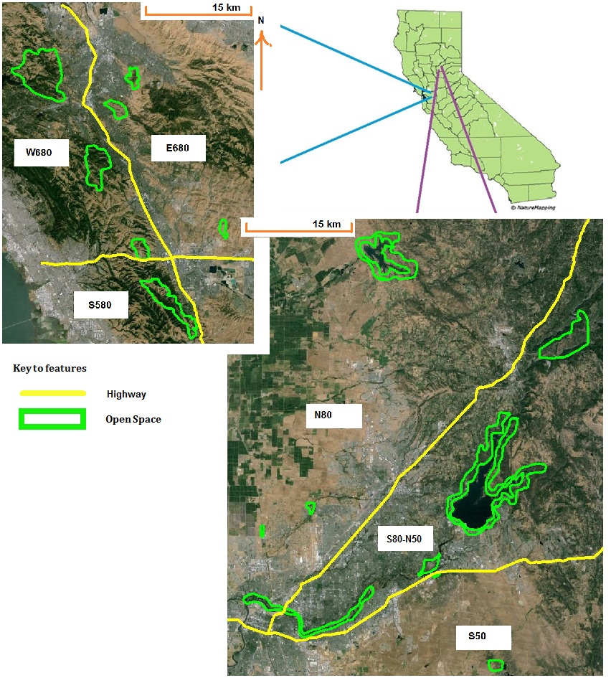

**Figure 1. Map of study area and coyote sampling locations (in green). A) Bay Area sampling locations along I-580 and I-680. I-580 runs West-East, I-680 runs North-South. B) Sierra Nevada Foothill sampling locations along SR 50 and I-80. SR 50 runs West-East and I-80 runs Southwest-Northeast.**

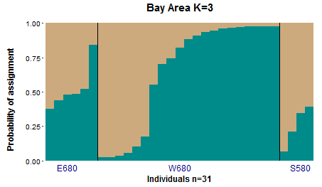

**Figure 2. Bar plot depicting individual assignments for coyotes sampled in the Bay Area. Each color corresponds to a genetic cluster identified by STRUCTURE, each bar corresponds to an individual sample, and the proportion of color in each bar depicts an individual’s proportional ancestry in each genetic cluster.**

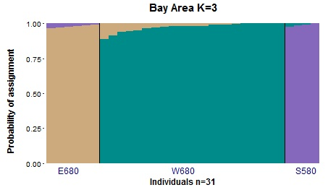

Figure 3. Structure bar plot illustrating expected patterns of population structure if Bay Area highways 1-680 and I-580 were acting as impermeable barriers to coyote movement.

# References

Atkinson, K. T. and D. M. Shackelton. 1991. Coyote, *Canis latrans*, Ecology in a Rural-Urban environment. The Canadian Field-Naturalist 105: 49-54.

California State Transportation Agency, Department of Transportation. 2014 traffic volumes on the California state highway system.

Charry B, Jones J (2009) Traffic Volume as a Primary Road Characteristic Impacting Wildlife: A Tool for Land Use and Transportation Planning. Proc 2009 Int Conf Ecol Transp 159–205.

Clark RW, Brown WS, Stechert R, Zamudio KR (2010) Roads, interrupted dispersal, and genetic diversity in timber rattlesnakes. Conserv Biol 24:1059–1069. doi: 10.1111/j.1523-1739.2009.01439.x

Coffin AW (2007) From roadkill to road ecology: A review of the ecological effects of roads. J Transp Geogr 15:396–406. doi: 10.1016/j.jtrangeo.2006.11.006

Delaney KS, Riley SPD, Fisher RN (2010) A Rapid, Strong, and Convergent Genetic Response to Urban Habitat Fragmentation in Four Divergent and Widespread Vertebrates. PLoS One 5:e12767. doi: 10.1371/journal.pone.0012767

Ernest HB, Vickers TW, Morrison S a, et al. (2014) Fractured Genetic Connectivity Threatens a Southern California Puma (Puma concolor) Population. PLoS One 9:e107985. doi: 10.1371/journal.pone.0107985

Evanno G, Regnaut S, Goudet J (2005) Detecting the number of clusters of individuals using the software STRUCTURE: a simulation study. Mol Ecol 14:2611–2620. doi: 10.1111/j.1365-294X.2005.02553.x

Frankham R (1996) Relationship of genetic variation to population size in wildlife. Conserv Biol 10:1500–1508.

Gerlach G, Musolf K (2000) Fragmentation of landscape as a cause for genetic subdivision in bank voles. Conserv Biol 14:1066–1074. doi: 10.1046/j.1523-1739.2000.98519.x

Goslee AS, Urban D, Sarahgosleearsusdagov MSG (2015) Package “ ecodist .”

Grinder MI, Krausman PR (2001) Home range, habitat use, and nocturnal activity of coyotes in an urban environment. J Wildl Manage 65:887–898. doi: 10.2307/3803038

Grubbs SE, Krausman PR (2009) Use of Urban Landscape by Coyotes. Southwest Nat 54:1–12.

Holzhauer SIJ, Ekschmitt K, Sander AC, et al. (2006) Effect of historic landscape change on the genetic structure of the bush-cricket Metrioptera roeseli. Landsc Ecol 21:891–899. doi: 10.1007/s10980-005-0438-9

Hubisz MJ, Falush D, Stephens M, Pritchard JK (2009) Inferring weak population structure with the assistance of sample group information. Mol Ecol Resour 9:1322–1332. doi: 10.1111/j.1755-0998.2009.02591.x

Jakobsson M, Rosenberg N a (2007) CLUMPP: a cluster matching and permutation program for dealing with label switching and multimodality in analysis of population structure. Bioinformatics 23:1801–1806. doi: 10.1093/bioinformatics/btm233

Kalinowski ST (2005) Hp-Rare 1.0: a Computer Program for Performing Rarefaction on Measures of Allelic Richness. Mol Ecol Notes 5:187–189. doi: 10.1111/j.1471-8286.2004.00845.x

Marsh DM, Milam GS, Gorham NP, Beckman NG (2005) Forest roads as partial barriers to terrestrial salamander movement. Conserv Biol 19:2004–2008. doi: 10.1111/j.1523-1739.2005.00238.x

Nei M (1972) Genetic distance between populations. Am Nat 106:283–292.

Nei M (1978) Estimation of average heterozygosity and genetic distance from a small number of individuals. Genetics 89:583–590.

Peakall R, Smouse PE (2012) GenAlEx 6.5: genetic analysis in Excel. Population genetic software for teaching and research--an update. Bioinformatics 28:2537–2539. doi: 10.1093/bioinformatics/bts460

Peakall R, Smouse PE (2006) GENALEX 6: genetic analysis in Excel. Population genetic software for teaching and research. Mol Ecol Notes 6:288–295. doi: 10.1111/j.1471-8286.2005.01155.x

Pritchard JK, Stephens M, Donnelly P (2000) Inference of population structure using multilocus genotype data. Genetics 155:945–959.

Reusch TBH, Ehlers A, Hämmerli A, Worm B (2005) Ecosystem recovery after climatic extremes enhanced by genotypic diversity. Proc Natl Acad Sci U S A 102:2826–2831. doi: 10.1073/pnas.0500008102

Rice WR (1989) Analyzing tables of statistical tests. Evolution (N Y) 43:223–225.

Riley SPD, Brown JL, Sikich JA, et al. (2014a) Wildlife Friendly Roads: The Impacts of Roads on Wildlife in Urban Areas and Potential Remedies. Urban Wildl. Conserv. Theory Pract. Springer Science+Business Media, pp 323–360

Riley SPD, Pollinger JP, Sauvajot RM, et al. (2006) A southern California freeway is a physical and social barrier to gene flow in carnivores. Mol Ecol 15:1733–1741. doi: 10.1111/j.1365-294X.2006.02907.x

Riley SPD, Serieys LEK, Pollinger JP, et al. (2014b) Individual behaviors dominate the dynamics of an urban mountain lion population isolated by roads. Curr Biol 24:1989–1994. doi: 10.1016/j.cub.2014.07.029

Sacks BN, Mitchell BR, Williams CL, Ernest HB (2005) Coyote movements and social structure along a cryptic population genetic subdivision. Mol Ecol 14:1241–1249. doi: 10.1111/j.1365-294X.2005.02473.x

Sawaya M a, Kalinowski ST, Clevenger AP (2014a) Genetic connectivity for two bear species at wildlife crossing structures in Banff National Park. Proc Biol Sci 281:20131705. doi: 10.1098/rspb.2013.1705

Sawaya MA, Kalinowski ST, Clevenger AP (2014b) Genetic connectivity for two bear species at wildlife crossing structures in Banff National Park Genetic connectivity for two bear species at wildlife crossing structures in Banff National Park. Proc R Soc London B 281:20131705.

Schreier AD, Mahardja B, May B (2013) Patterns of Population Structure Vary Across the Range of the White Sturgeon. Trans Am Fish Soc 142:1273–1286.